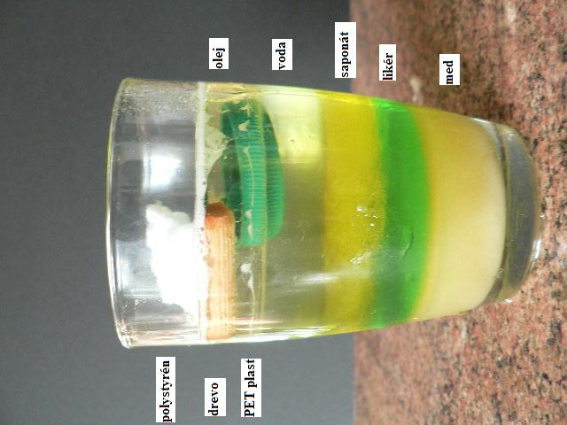

http://www.oskole.sk/?id_cat=3&clanok=18667